CO1- AT2
DSA0603- Data Handling and Visualization

G.Yaswitha
192325087
AIML

- library(ggplot2)

data <- data.frame(
Country = c("C1","C2","C3","C4","C5"),
GDP = c(12.5,8.2,21.0,3.1,5.6),
Literacy = c(92,88,95,75,80),
Population = c(140,65,330,210,95),
Continent = c("Asia","Europe","N. America","S. America","Africa")
)

ggplot(data, aes(GDP, Literacy, size=Population, color=Continent)) +
geom_point()

Output

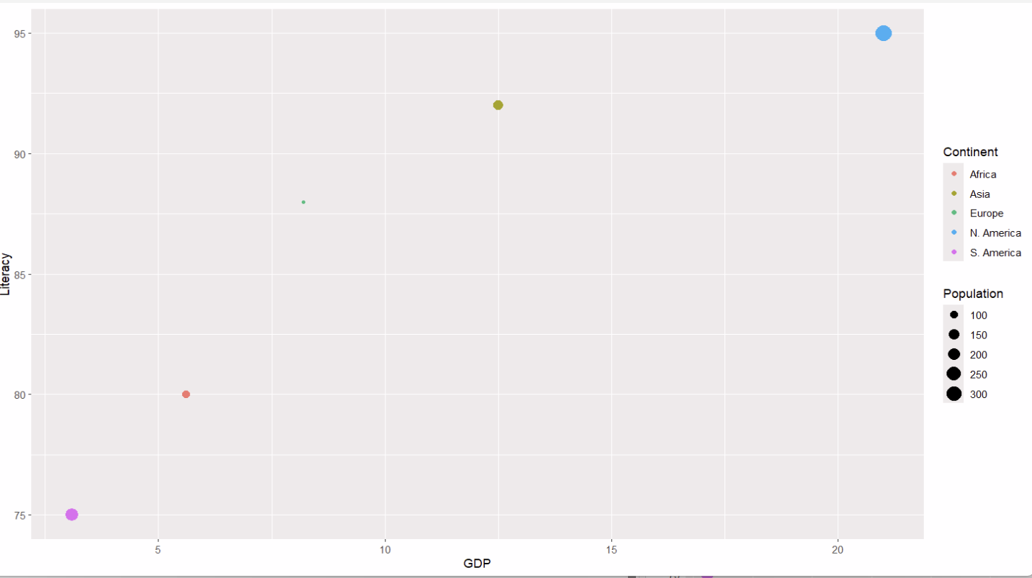
2.library(ggplot2)

data <- data.frame(
GDP = c(12.5,8.2,21.0,3.1,5.6),
Literacy = c(92,88,95,75,80),
Population = c(140,65,330,210,95),
Continent = c("Asia","Europe","N. America","S. America","Africa")
)

ggplot(data, aes(
x = GDP,
y = Literacy,
size = Population,
color = Continent
)) +
geom_point()

Output
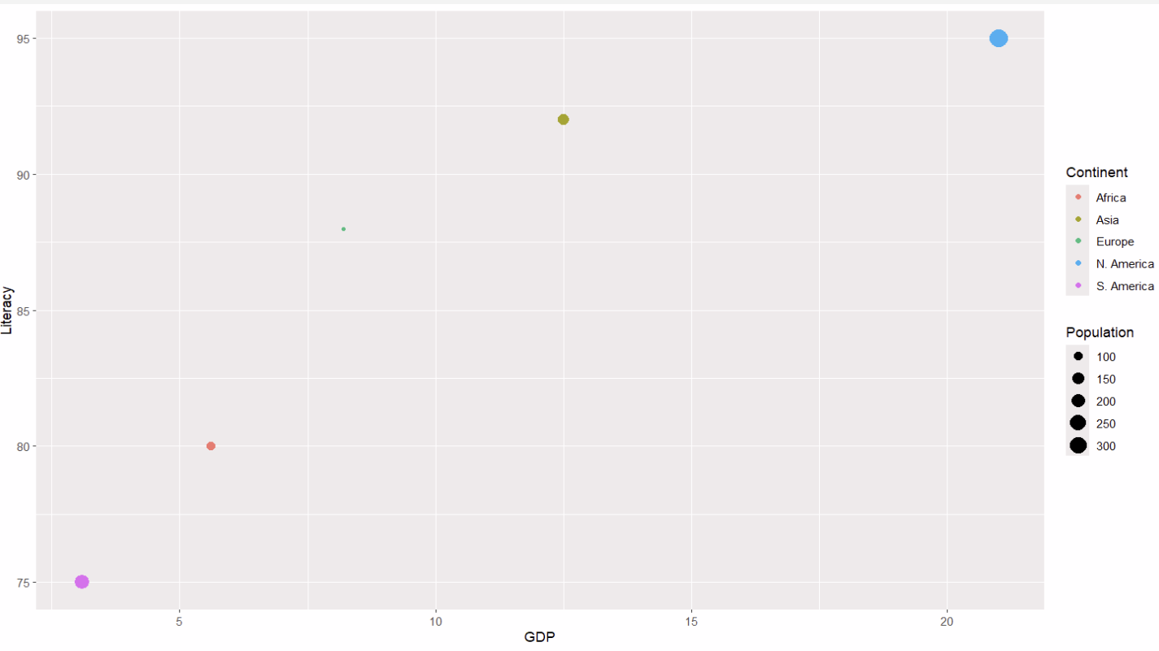
3.library(ggplot2)

data <- data.frame(
GDP = c(12.5,8.2,21.0,3.1,5.6),
Literacy = c(92,88,95,75,80)
)

ggplot(data, aes(GDP, Literacy)) +
geom_point() +
geom_smooth(method="lm")

Output:
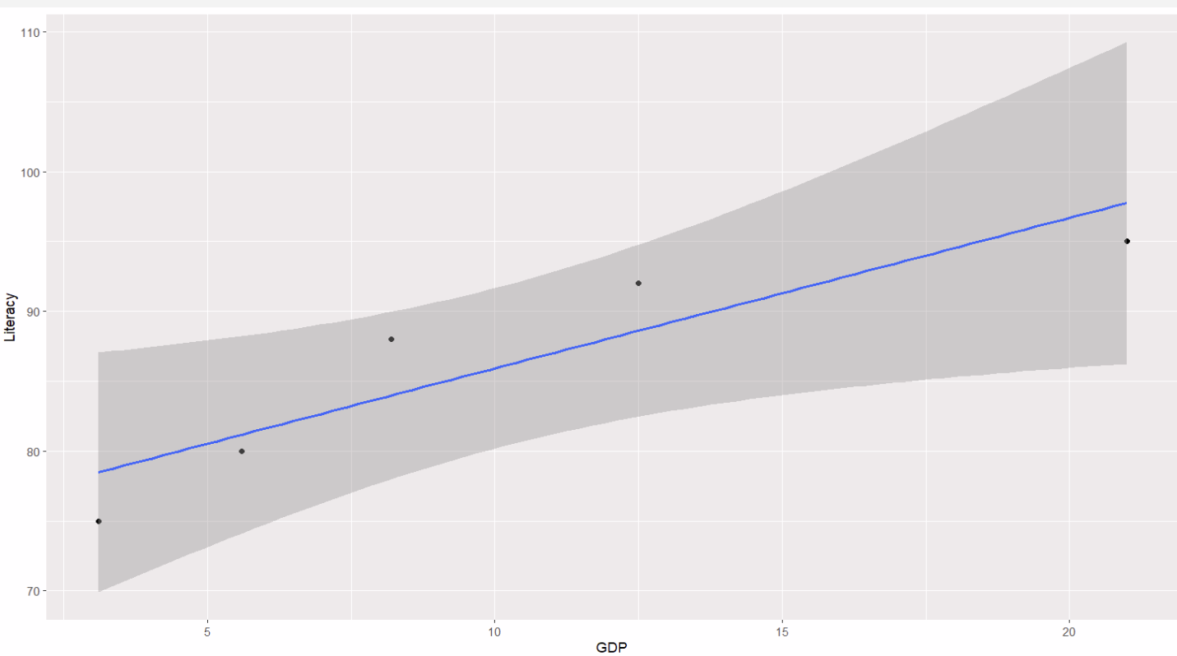

4.data <- data.frame(
Country = c("C1","C2","C3","C4","C5"),
GDP = c(12.5,8.2,21.0,3.1,5.6),
Literacy = c(92,88,95,75,80),
Population = c(140,65,330,210,95),
Continent = c("Asia","Europe","N. America","S. America","Africa")
)

str(data)

Output:
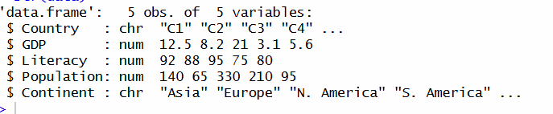

5.library(ggplot2)

data <- data.frame(
Country = c("C1","C2","C3","C4","C5"),
GDP = c(12.5,8.2,21.0,3.1,5.6),
Literacy = c(92,88,95,75,80),
Population = c(140,65,330,210,95),
Continent = c("Asia","Europe","N. America","S. America","Africa")
)

ggplot(data, aes(GDP, Literacy,
size=Population,
color=Continent)) +
geom_point(alpha=0.6) +
geom_text(aes(label=Country), vjust=-1) +
theme_minimal()

Output:
